Arduino package installation – MMA8451 accelerometer libraries

Steven Hammer [s.hammer@hw.ac.uk](mailto:s.hammer@hw.ac.uk) 28/09/2020

# Installing packages

For some Arduino tutorials, an additional library file is required to operate the components correctly. In one example, an Adafruit MMA8451 accelerometer is used which needs a library installation to function properly.

To install the library, go to the Tools menu in the Arduino IDE and select “Manage Libraries”.

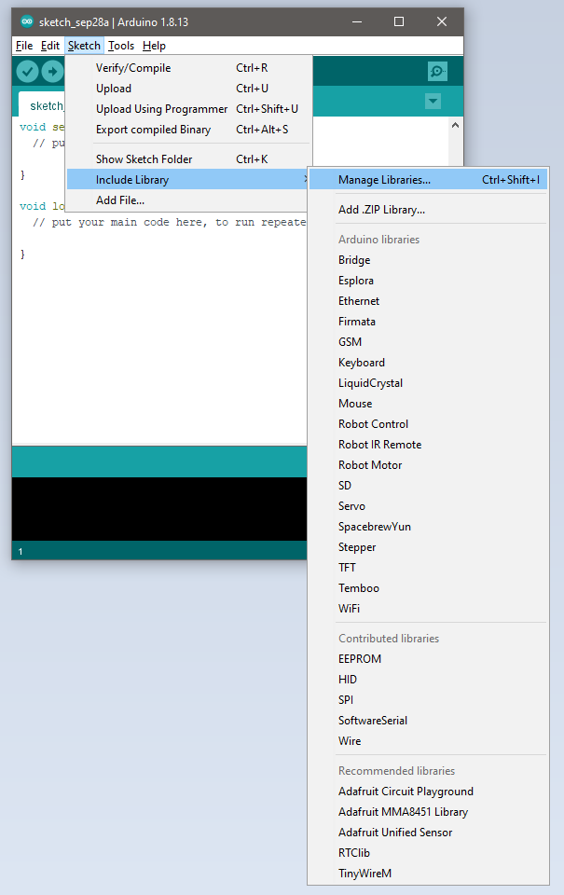

The Library Manager window should appear.

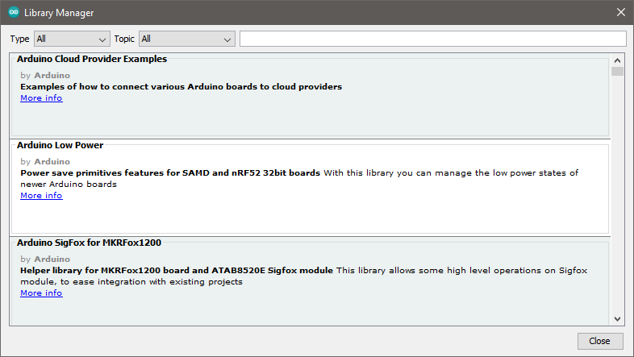

Search for “MMA8451” in the search box at the top of the window.

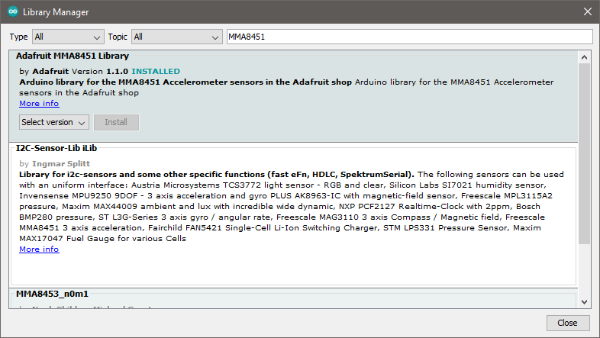

To install the library, click on the “Install” button.

Once the library is installed correctly, if you select “Sketch -> Include Library” then “Adafruit MMA8451 Library” should appear in the “Recommended Libraries” section of the menu.

You should then put

#include <Adafruit_MMA8451.h>

before the void setup() statement in the Arduino sketch to allow your code to control the accelerometer.